**Brooklyn torah gazette**

**For parshas vayechi 5780**

Volume 4, Issue 18 (Whole Number 170) 14 Teveth 5780/ January 11, 2020

**Printed L’illuy nishmas Nechama bas R’ Noach, a”h**

For a free subscription, please forward your request to [***keren18@juno.com***](mailto:keren18@juno.com)

*Reprinted from the November 22, 2019 edition of the Flatbush Jewish Journal.*

**Crown Heights Under G-d, Under Siege**: **Anti-Semitic Crime Wave Mystifies Chasidim**

**By Jonathan Marks.**

[](https://static.timesofisrael.com/jewishwdev/uploads/2020/01/01-bot.jpg)

**A Shomrim mobile command center next to an NYPD cruiser on the streets of Crown Heights Monday. Jonathan Mark/JW**

The streets of Crown Heights are haunted by madness, a “slow-motion pogrom,” said a chasid, that has only intensified in recent weeks. There have been random beatings, women having their wigs pulled off and an intimidation of Jews that started months ago, even years ago, according to some calculations.

Incidents without injuries have become so frequent that they rarely enter Jewish conversations outside the neighborhood. While the Chanukah machete attack in upstate Monsey was widely discussed, few Jews outside Crown Heights knew that the night before, a man entered Chabad’s main shul at 770 Eastern Parkway, during Friday night davening, and started yelling, “Kill, kill, kill,” according to court papers. He’s being held without bail.

Every day, another neighborhood story. Col-Live, a Chabad news site, displayed footage from a security camera near Albany Avenue of black men throwing a chair and hitting a chasidic man in the head on Dec. 24.

The almost daily crime and harassment during Chanukah has brought an infusion of police to Crown Heights. On Monday, a state trooper could be seen outside 770, which is also Chabad-Lubavitch headquarters and the site of its vast study hall. Two large white mobile command centers were parked near 770, one from the police, one — with a flashing menorah — from Chabad’s Shomrim volunteer security group.

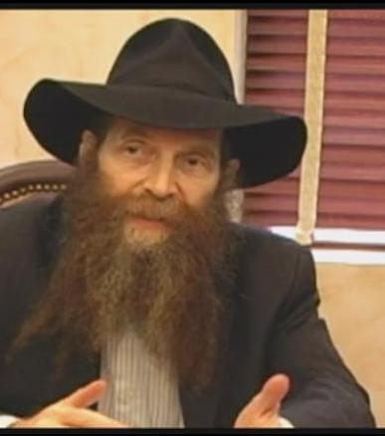

**Rabbi Eli Cohen**

“As much as City Hall’s giving, it’s not enough,” said Rabbi Eli Cohen of the Crown Heights Jewish Community Relations Council. “The mayor announced he would do more, and then I saw that ‘more’ simply means four or six officers per shift. That’s two or three police cars; what we need is four to six cars. It’s a pretty big area,” more than a mile across. The mayor called this week for increased police patrols at Jewish institutions, better street lighting, Neighborhood Safety Coalitions comprised of New Yorkers from diverse backgrounds, and inserts into the school curriculum that address anti-Semitism.

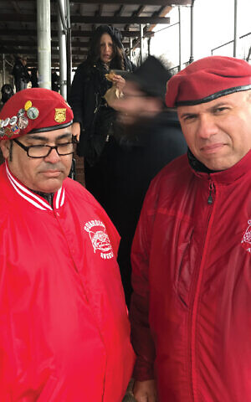

**Guardian Angels members Edwin Caracalla,**

**left, and Benjamin Garcia in Crown Heights**

**this week. Jonathan Mark/JW**

Although there have been a number of threatening intrusions into the shul at 770, a place as crowded as a December department store, there is no guard or security pat-down at its entryways.

And yet, on a cold and rainy day, all seemed well. Lubavitch Youth posters asked, “How are you lighting up another Yid’s Chanukah? Bring a Chanukah party to the elderly or visit Jewish families in local apartment buildings.” There were lines in the bagel store and pizza shops, and tourists, mostly non-Jews and Europeans, were unafraid, waiting at “Jewish Brooklyn” on Kingston Avenue for Yoni Katz’s highly regarded walking tour of chasidic Crown Heights.

Come sundown, though, caution prevailed. In the tour office, Rabbi Shlomo Friedman told us, “People are looking over their shoulder. Women are less likely to go out after dark, or they walk in pairs.” Others in the neighborhood noticed that chasidic parents are placing restrictions on their usually “free range” children.

The Guardian Angels, an unarmed safety patrol group that had its heyday back in the ’80s, announced it was prepared to intervene in fights, make citizen’s arrests and alert the police to incidents. It is deploying three shifts in Crown Heights, operating around the clock, said Benjamin Garcia, 56, a Guardian who lived in the Bronx.

“We’ll have from 10 to 20 of us,” in teams of two or three, visibly on the street, said Garcia, a sergeant with the New York City police reserve. Outside 770, earlier in the day, women were running over to thank the Guardian Angels. “I was here in 1991,” recalled Garcia, when three days of anti-Semitic rage, violence and home invasions convulsed — and still traumatize — Crown Heights.

“And I came yesterday,” following the Monsey attack. “It’s very tragic what we’ve been hearing. People see the red berets,” the famous Guardian Angel uniform, along with their red jackets, and “they’re less stressed. They know we’re looking out for these great people. The more people looking out, the more eyes and ears, the better.”

Feeling Abandoned

In the shuls and shops, Chabad neighbors charged that they were abandoned by local politicians, who say all the right things but have instituted legislation that the chasidim feel is protecting criminals rather than the victims. Rabbi Cohen, of the Crown Heights JCRC, was frustrated by recent bail reform, which eliminates bail or the court’s option to deny bail for many misdemeanors and harassments that happen to include most anti-Semitic crimes. There have been more than 150 of these crimes, mostly in Brooklyn, in 2019.

For example, Tiffany Harris, 30, was arrested Dec. 28 for hitting three chasidic women near 770, yelling “FU, Jews,” when she was detained by police. She was freed without bail, and the next day punched a Jewish woman in the eye.

Rabbi Cohen said, “I understand why they wanted to reform the bail process, but we need something in its place to keep the streets safe. When something is obviously a hate crime they need to be able to hold someone who is a serious threat to commit another hate crime.”

Some locals said that some crimes were not being reported because of another new reform, the Discovery for Justice Reform Act, that could require the police to give the accusing victim’s personal information to his attackers.

There have been various attempts at denting the crime wave by educating children. For several months, Cohen, together with Geoffrey Davis, an African-American district leader in Crown Heights, have been meeting with more than a thousand students “from nursery through high school,” said Cohen. “Geoffrey and I tried to share our friendship with them.” They talk to the children about bullying, gentrification, stereotyping, “while modeling a positive Jewish-black relationship.”

Last week, in a separate project, U.S. Rep. Hakeem Jeffries and Brooklyn Borough President Eric Adams announced a “Breaking Bread” initiative to invite children, in groups of 10, to 100 dinners, and educate them about anti-Semitism. Adams said that hate stems from ignorance, people not knowing each other, not knowing history. “Many of them didn’t know the significance of the swastika,” he said.

But one Chabad mother told us, “There are many Jews who think a smile and a handshake, and a seder meal, will make them love us. It’s very painful to me. There needs to be education, but this is beyond children’s education. When you’re dealing with maniacs, mentally ill people, wild people who seriously hate Jews, can that really be solved with a ‘Be nice, don’t hate’ program?”

While others did like the idea of cross-cultural dinners, there were some in Crown Heights who thought that that train left the station a long time ago. These Jews — who remembered the home invasions during the 1991 riots — were talking of buying guns.

We asked the Chabad mother what she thought of guns. “Let’s put it this way,” she said. “I don’t think we should have laws that will take guns away. Guns for an individual’s protection? I know that in shuls, people have them, quietly. Oh, I never thought I would ever be talking like this, or even thinking like this.”

Told that in shul some men were saying it was time to call out the National Guard, or to ask the government to declare a state of emergency, the mother replied, “I hope not. I hope we’re not at that point.”

Cohen takes solace from a big difference from 1991: “Today, the black religious leadership and political leadership are on board with us, they really want to see this neighborhood come together.”

Cohen’s community council has been doing more than talking to children. They’re interacting with adults. CHJCRC has a storefront operation on Kingston Avenue offering anyone advice on social work services: medical insurance, food stamps, immigration, government services, senior services, rent subsidies, and replacing boilers in public housing, to name a few.

Cohen added, “Negativity comes out of a sense of randomness, meaninglessness, a lack of direction. As the Rebbe [Menachem Mendel Schneerson, the late leader of the Chabad movement] said in 1991, we have to bring more goodness and kindness into the world, to make the world a more godly place. I guess if we’re not doing it, it comes to our doorstep and we’re forced to do it.

“You can never put enough policemen on the block,” said Cohen. “What’s more important is to teach a child that even when you think no one is watching, Someone is watching.”

*Reprinted from the January 1, 2020 website of the New York Jewish Week.*

**Jews Are Going Underground**

**By Devorah Lipstadt**

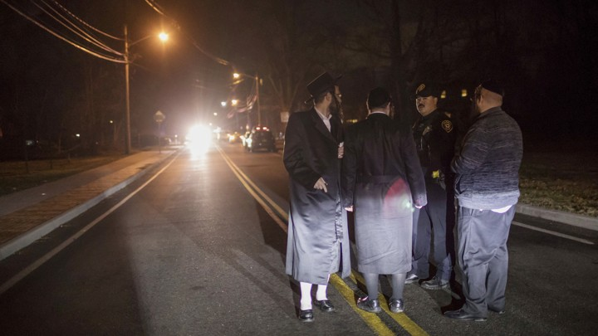ASSOCIATED PRESS

In a month of terrible anti-Semitic attacks, including a stabbing yesterday of multiple people at a Hanukkah celebration at a rabbi’s home in Monsey, New York, the news that most depressed me did not involve violence. It was not something done *to*Jews but something Jews *did.*A [synagogue in the Netherlands](https://www.politico.eu/article/netherlands-synagogue-invitation-only-groningen/) is no longer publicly posting the times of prayer services. If you want to join a service, you have to know someone who is a member of the community.

Do not misunderstand me. I was and am in a fury over the multiple assaults, culminating in the Monsey attack, which was the worst since the murders in [Jersey City](https://www.nytimes.com/2019/12/11/nyregion/jersey-city-shooting.html), which, some readers might not realize, was less than three weeks ago.

In Europe and the United States, Jews have been repeatedly assaulted on the street. Tombstones were [desecrated](https://jewishjournal.com/news/world/308586/nearly-60-jewish-graves-desecrated-in-slovakia/) in Slovakia. In London, anti-Semitic graffiti was [painted](https://www.theguardian.com/uk-news/2019/dec/29/london-synagogue-and-shops-targeted-with-antisemitic-graffiti) on synagogues and Jewish-owned stores.

A Belgian daily newspaper [accused](https://www.jta.org/2019/12/23/global/belgian-daily-accuses-jewish-lawmaker-of-spying-for-israel?mpweb=1161-15727-33161) a lawmaker who is Jewish of being a spy for Israel. A Polish town [refused](https://www.jta.org/quick-reads/polish-city-refuses-to-install-memorial-stones-for-holocaust-victims) to install small brass plates that commemorate Holocaust victims. In Italy, the town of [Schio](https://www.jpost.com/Diaspora/Italian-town-says-no-to-Holocaust-Memorial-calling-it-divisive-609603) did the same because, the mayor said, they would be “divisive.” (Divisive to whom?) This intolerance is coming from right-wing extremists, progressive leftists, and other [minorities](https://www.theatlantic.com/ideas/archive/2019/12/political-inconvenience-jersey-city-shooting/603472/) who, themselves, are often the object of persecution. Anti-Semites seem to think it is open season on Jews. And maybe, given the many incidents, they are right.

So why has the news that a synagogue in the Netherlands stopped posting the time of services upset me above all? Because it is vivid proof that anti-Semitism is driving Jews underground in the West.

For some time now, many kippah-wearing Jews have adopted the habit of wearing baseball caps when visiting Europe. Young people think twice before wearing Israeli-flag T-shirts when they wander the streets of Paris. Or before carrying a backpack with the name of their Jewish youth group prominently displayed. A number of years ago, I met a Jewish woman from Brussels who told me that she had asked her teenage children not to wear their Jewish-star necklaces in public. She acknowledged that she was embarrassed to have asked them and relieved when they agreed.

During a trip to Berlin, a friend gave me directions to an out-of-the-way synagogue. After some intricate explanations, he added that if I got lost, I should look for police on the street with submachine guns. “That,” he noted, “would be the entrance to the synagogue.” But I should also keep watch for men in baseball caps and follow them. “They will lead you to the synagogue.” I did get lost, and followed some men in baseball caps as instructed. I was relieved when I saw the police. I had found it.

For many years, Jews have known that when visiting a European synagogue, they must bring their passport with them and expect to be interrogated by guards outside the door. I now call ahead to let a synagogue know that I am coming. And that does not always guarantee entry. A few years ago, I was turned away from a synagogue in Rome.

Jews have been living defensively for a long time. But when a synagogue, as a precaution, decides not to post the time of services, we have reached a new level. In Spain in the 15th century, many Jews sought safety from persecution by converting to Christianity but secretly maintained their Jewish practices. They lit Shabbat candles in inner reaches of their homes where no one from the street could see, and eschewed eating pork or shellfish.

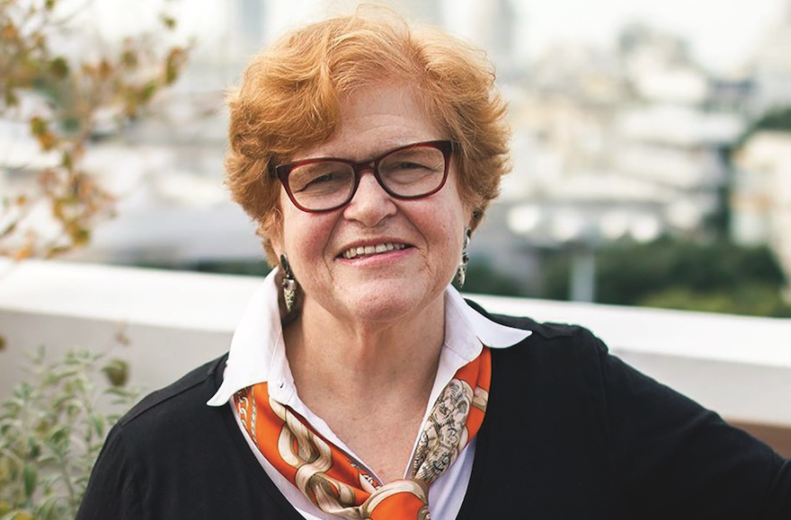

**Deborah Lipstadt**

They became what Spaniards called *Marranos,*a term of degradation comparable in some ways to *kike*. Some Jews who converted did not maintain the traditions. This did not, of course, guarantee their safety when the Church, state authorities, and the mob began to seek out *Marranos* for persecution.

I use the term, however reluctantly, because it captures what I am seeing today. Most Jewish students on American campuses have not been subjected to overt acts of discrimination or verbal abuse. But many among them feel they have something to lose if they openly identify as Jews.

If they are active in Hillel, the Jewish student organization, they may be informally barred from being active in progressive causes—for example, racial and LGBTQ equality, climate-change mitigation, and the fight against sexual assault. Those who want to be elected to student government are learning to scrub their résumés clean of any overtly Jewish or pro-Israel activities. They are not abandoning their Jewish identity; they are hiding it. They have become *Marranos.*

When Jews feel it is safer for them to go “underground” as Jews, something is terribly wrong—wrong for them and, even more so, wrong for the society in which they live. Jews have taken and are taking anti-Semitism very seriously. Non-Jews must do the same.

You must do so, not solely for the sake of the well-being of your Jewish neighbors, friends, and fellow citizens. (Though that would be laudable.) You must do so for the sake of the well-being of the societies in which you live. No healthy democracy can afford to tolerate anti-Semitism in its midst. It is one of the long-term signs of rot in that democracy. If you care about democracy, you should care about the Jews among you, and the anti-Semites too.

*We want to hear what you think about this article.*[*Submit a letter*](https://www.theatlantic.com/contact/letters/)*to the editor or write to letters@theatlantic.com.*

[**DEBORAH LIPSTADT**](https://www.theatlantic.com/author/deborah-lipstadt/)*teaches Holocaust history at Emory University and is the author, most recently, of*[Antisemitism: Here and Now](https://www.amazon.com/Antisemitism-Here-Deborah-Lipstadt/dp/0805243372)*.*

*Reprinted from the December 29, 2019 website of The Atlantic*

**The Shmuz onParshas Vayichi**

# **Discretion**

**By Rabbi Bentzion Shafier**

**Founder of TheSmuz.com**

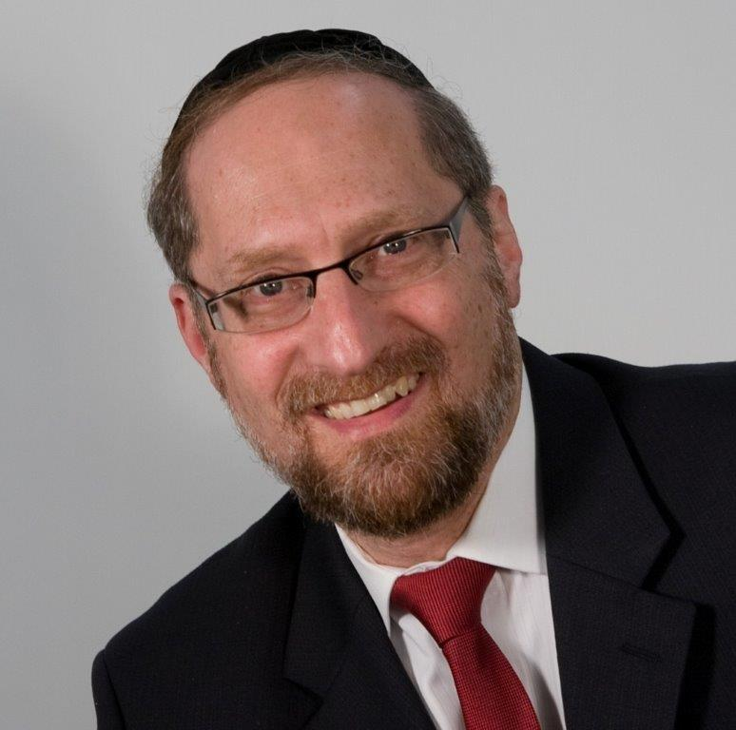

*But as for me-- When I travelled from Padam, Rochel died on me in the land of Canaan on the road, while there was still about a beras of land to go Ephras; and I buried her there on the road in Ephras, which is Bethlechem*. Bereishis 48:7

Yaakov Avinu spent the last 17 years of his life in Mitzraim. For the first time in many, many years, he lived in peace and tranquility, and in that state finishes off his stay on this planet. Near the very end of his days, he calls in his beloved son Yosef to make an impassioned request: “Please do not bury me in Mitzraim.”

Rashi tells us that after this event, when Yaakov felt he had little time left, he blesses the children of Yosef, when your mother Rochel died I buried her on the road. Rashi explains that Yaakov has a specific reason to mention that fact now of all times, as this might be his final address to his son and then said to Yosef:

“I know that for many years you had a complaint against me, When your mother died, why didn’t I bring her to a city to be buried, why did I bury her literally on the side of the road. You should know that I was commanded by HASHEM to do this for the sake of the Jewish Nation.

“When Nevuzaradan will be exiling the Jews, they will pass by this road. Rochel will cry out with bitter weaping, for HASHEM to have mercy, those cries alone will save the people. Not the entreaties of the Avos, not the begging of the Imaos, only her voice calling out will move HASHEM to mercy. I buried her there, because HASHEM told me to do that for the sake of the Klal Yisroel, I had to do it.

“When I was travelling from Lavan’s house, Rochel, your mother died and I buried her there.” Rashi explains what Yaakov was actually saying:

I know that for many years you had bad feeling against me

The Siftei Chachmim explains why: I am not the bearer of bad tidings. There will be many bad events, much suffereing that will face the Jewish Nation, I have to tell you about them, when I have to, but not a moment sooner.

Yosef was not a fragile youth who would fall apart if he heard bad news. He was, a mature, sophisticated Talmid Chacham, his role at the time was leader of all of of Mitzraim, he wasn’t going to fall apart at the sound of some bad news. And Yaakov knew that eventually he was going to have to tell him anyway. Why not just tell him now, and eliminate the bad feelings that Yosef felt towards his father.

The sensitivity of a Tzadik

The answer to this question is that Yaakov Avinu was extraodinarly guarded in what he said. Every word measured, every expression weighed. Never did a stray word come out of his mouth. He had a policy, I am not the bearer of bad tidings. If I tell you why I buried your mother on the road, I will have to tell you why.

The why has to do with the fact that the Jewish Nation will be sent into exile, and she will be there, on the road to beg mercy for them. That is bad news. That is troubling news. I have a policy I am not the bearer of bad tidings. When you have to hear the bad news, I will tell you, but not before.

**The discretion of the man**

The sensitivity of a Tzadik and the discretion of the man I can’t cause you pain. I can’t be the one to break the news to you and cause you to suffer any earlier than I have to. I would rather shoulder the blame for something that I didn’t do. Have my beloved son have false claims against me, than to bring him pain.

This is a powerful example of discretion of a man watching his every word and every expression

*Reprinted from this week’s website on TheShmuz.com This is an excerpt from the [Shmuz on the Parsha book](https://theshmuz.com/product/shmuz-on-the-parsha-book/).*

**Learning from Joseph How**

**Jews Can Overcome Obstacles**

**From the Talks of the Lubavitcher Rebbe**

**Rabbi Menachem Mendel Schneerson, Zt”l**

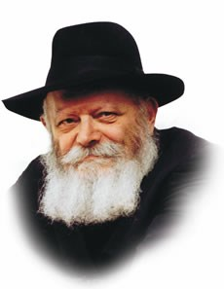

With this week's Torah portion, Vayechi, we conclude the Book of Genesis. "So Joseph died, being one hundred and ten years old...and he was put into a coffin in Egypt" is its final verse.

This conclusion to the entire Book is somewhat surprising, in light of the principle that "one should always end on a positive note." Why couldn't Genesis have concluded a few verses back, when we learn that Joseph lived a long life and merited to see grandchildren and great-grandchildren?

Why couldn't the description of Joseph's death have waited until the Book of Exodus?

We must therefore conclude that Joseph's passing is somehow related to the theme of Genesis itself.

The primary difference between Genesis and the other four Books of Moses is that Genesis relates the early history of our Forefathers and the twelve tribes -- the preparation for our existence as a distinct nation -- whereas the other four books contain a narrative of our history as a people.

The Book of Genesis begins with an account of the creation of the world.

The Sage, Rabbi Yitzchak, explained that although the Torah should have begun with a practical mitzva, G-d chose to commence with the Creation to refute the arguments of the Gentiles, who would one day claim that the Jews had stolen the land of Israel from the seven nations who lived there prior to its conquest.

To counter their assertion, the Jews will say, "The entire world belongs to G-d; He created it and divided it as He saw fit. It was His will to give it to them [the seven nations], and it was His will to take it from them and give it to us."

Surely G-d did not change the entire order of His Torah just to supply an answer to the arguments of the Gentiles. The comments of Rabbi Yitzchak must therefore contain a more fundamental teaching for the Jewish people as a whole.

The nations of the world are already cognizant of the Jew's uniqueness and his special mission. Their claim, however, is that precisely because Jews are different, they should limit themselves to the spiritual service of G-d and not tie themselves down to a physical land.

Because Jews are a nation like no other, they have no right to claim ownership of a homeland. To the non-Jew, the spiritual and physical realms are incongruous and incompatible.

"The entire world belongs to G-d," the Jew responds -- the worldly as well as the spiritual realm.

Both require sanctification through the light of holiness -- the sacred mission of the Jewish people.

With this concept the Book of Genesis begins, and on this note it concludes. Joseph's coffin remained in Egypt in order to give strength and inspiration to the Children of Israel in their Egyptian exile. The power of Joseph is symbolic of the ability of the Jewish people to overcome even the most difficult of obstacles, imbuing even the coarsest of physical matter with holiness and bringing the full and complete Redemption.

*Reprinted from the Issue #345 of L’Chaim Weekly (Parashat Mikeitz 5755/1994)*

**Resisting Negative Inflences**

**By Rabbi Eli J. Mansour**

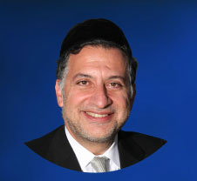

The Torah tells in Parashat Vayechi of the blessings Yaakov bestowed upon his children before his passing.  Surprisingly, even before he assembles his sons to bless them, he confers a special blessing upon two of his grandsons – Efrayim and Menashe, Yosef's two sons.

Rabbi Yaakov Kaminetzky raised the question of why Yaakov would single out two of his many grandsons to receive a special blessing. One of the clearest lessons that emerge from the entire story of Yosef and his brothers is the dangers of affording preferential treatment to one son over the others.

After all, it was Yaakov's preferential treatment of Yosef that aroused the brothers' jealousy in the first place, which ultimately resulted in his sale as a slave to Egypt. How, then, could Yaakov allow himself to single out two of his grandsons, Efrayim and Menashe, rather than bestowing this blessing upon all his grandchildren?

Rabbi Kaminetzky explained that Efrayim and Menashe required a special blessing because of the surroundings in which they were born and raised.  Yaakov's other grandchildren were born and raised in the Land of Israel, in the company of their righteous grandfather and uncles. They received a Torah education and grew in an environment characterized by religious values and spirituality.

**Yosef’s Children Were Raised in the Most Corrupt**

**And Immoral Civilization of the Ancient World**

Yosef's children, on the other hand, were raised in Egypt, the most corrupt and immoral civilization of the ancient world. They were the only Jews in a culture of depravity and promiscuity, and undoubtedly this atmosphere affected them to some extent.  Rabbi Kaminetzky suggested that the name "Efrayim" itself perhaps give some indication of a small measure of Egyptian influence on Yosef's family. Several Egyptian names with which we are familiar from Chumash – such as Tzofnat Panei'ach, Potifar and Shifra – contain some or all of the three letters "Peh," "Ayin" and "Resh" – the three main letters of the title "Pharaoh."

It appears that Egyptians often chose names with these letters for the purpose of drawing an association to Pharaoh. The name Efrayim, too, contains the letters "Peh" and "Resh," suggesting that, to one extent or another, Yosef's family came under Egyptian influence.

And this should not surprise us. The Rambam, in one of his Halachot, writes, "The way a person is created is that he is drawn in thought and action after his peers and colleagues, that he acts in accordance with the behavior of the people of his locale."  Influence from one's surroundings is a natural force, as automatic as gravity.

**The Ramban Urges One to**

**Live Among Upstanding People**

It is human nature. The Rambam therefore urges one to live among upstanding people, who will impact upon him positively, and warns against living among sinful people, because of the dangerous negative influences to which one will then become subject.

According to the "Migdal Oz" commentary, the Rambam's source for this Halacha is the position of Bet Hillel recorded in the Talmud (Masechet Ketubot 17) as to how one compliments a bride at a wedding.  Bet Hillel holds that one should sing, "Kalla Na'a Va'chasuda" ("An attractive, graceful bride"), regardless of her appearance.

Apparently, Bet Hillel felt that even if a bride is unattractive, and she knows she is unattractive, she will nevertheless rejoice over receiving a compliment on her beauty.  So strong is the influence of other people's opinions that a person will take seriously even comments he knows to be insincere.  That Bet Hillel advocates complimenting an unattractive bride on her beauty, despite the clear insincerity of such a compliment, demonstrates just how affected we are by what others think.

Yet another example of the power of external influence can be seen in an experiment conducted in a university, by a professor who drew two lines on a blackboard, one two full inches shorter than the other. He then brought to the room seven students, six of whom had been informed ahead of time of the experiment.  The professor asked each of the six to identify the shorter of the two lines, and they – as they had been instructed – pointed to the longer line and identified it as the shorter one.

**The Powerful Pressure on the Seventh Student**

In 60% of the cases, the seventh student went along with his peers and pointed to the wrong line, despite seeing with his own eyes that it was actually longer.  And among the 40% who insisted on the correct response, 30% changed their minds after being pressured and ridiculed by the others.  Meaning, people are willing to think and speak irrationally, and in opposition to the plain and obvious reality they see before them, in order to conform to social trends.

It therefore behooves us to exercise extreme care in choosing the environments to which we allow ourselves and our children to be exposed.  This lesson is of particular importance this time of year, during which many people customarily leave on vacation.  One must be aware of the profound influence his surroundings exert upon him, and avoid settings and environments that compromise his spiritual standards.

Yaakov bestowed a special blessing upon Efrayim and Menashe, praying that they should be successful in resisting the threatening influences to which they had been subject since birth.  The results of Yaakov's blessing could be seen in the heroism of Efrayim's descendant, Yehoshua, who defiantly opposed his ten colleagues with whom he had scouted the Land of Israel.

The ten spies, prominent and respected leaders of the people, decided to speak negatively about the Land, whereas Yehoshua, in the face of immense pressure from his peers, stood by his values and championed the unpopular position, that Benei Yisrael should go and seize the Land.

When we bless our children on Friday night, "May G-d make you like Efrayim and Menashe," we should bear in mind this most crucial quality of Efrayim and Menashe – the ability to withstand societal pressure, and to do the right thing even when the world around us encourages doing otherwise.

*Reprinted from this week’s website of the Edmond J Safra Synagogue of Brooklyn website.*

**Rabbi Berel Wein on**

**Parashas Vayechi**

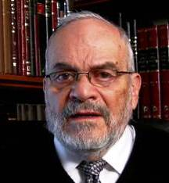

The conclusion of the book of Bereshith sets the stage for all of the remaining history of the Jewish people. Jacob and his family have settled in the land of Egypt, and live under the most favorable of circumstances. Their son and brother, Joseph, is the de facto ruler of the country that has provided them with prosperity. However, Joseph himself warns them that the situation is only temporary and that there are troubled days ahead.

He tells them that they will leave the land of Egypt, whether they wish to or not, and that when they leave they should remember him and take his bones with them, to be buried in the land of Israel, the home from which he was so brutally taken when he was about 17 years old.

I would imagine that the family of Jacob, when hearing these predictions of Joseph, were amazed, and probably were unable to fathom how their situation could change so drastically from greatness and wealth to slavery and persecution.

The Jewish people are by nature an optimistic people. We always believe that somehow things will turn out well, no matter how bleak the present circumstances may appear to be. Yet, only by remembering Joseph's words would the eventual redemption from Egyptian bondage be realized. Joseph's warnings would accompany them with his remains through the 40-year sojourn in the desert of Sinai. It would remind them to be aware of the historical dangers they would always have to face.

The conditions under which Jews have lived in exile and in the diaspora for millennia have always varied and fluctuated. But the basic message was that we were we were not really at home. We continually ignored warning signs, and somehow believed that things would get better. Ignoring the warnings of Joseph, many times in our history we doomed ourselves to tragedy and disaster.

If Joseph, the viceroy of Egypt, warned us that Egypt is not our home, then that message could not have been clearer to Jews in the coming millennia. But as the story of Egypt and the Jews unfolds in the book of Shemot, the majority of Jews forgot Joseph's message. And it remained only for Moshe himself to bring Joseph's bones out if Egypt for eventual burial in the Land of Israel.

The Torah will record for us that later Egyptian pharaohs and the Egyptian nation forgot about Joseph and his great accomplishments. The ironic tragedy is that much of the Jewish people as well forgot about Joseph and his message to them. In the annals of Jewish history, this forgetfulness on the part of Jews has often been repeated – and always with dire consequences.

The story of Joseph and of the Jewish settlement in Egypt provides the prototype for all future Jewish history. We always need to ask ourselves what Joseph would have to say about our current Jewish world. This is worthy of contemplation.

*Reprinted from this week’s website of Rabbiwein.co*

**Thoughts that Count**

*Jacob lived (Vayechi) in the land of Egypt seventeen years* (Gen. 47:28)

The best years of Jacob's life were equal to the numerical equivalent of the word "vayechi," which is thirty-four.

These were the seventeen years from Joseph's birth until he was sold, and the seventeen years Jacob spent in Egypt. *(Baal HaTurim)*

*I will divide them in Jacob, and scatter them in Israel* (Gen. 48:14)

"There are no poor, scribes or teachers of young children except from the tribe of Shimon," comments Rashi, the great Torah commentator. Jacob did not intend this only as a punishment, but as an antidote to Shimon's undesirable character trait of insolence. Jacob worried that if Shimon and Levi were wealthy, no one would be able to oppose them. He therefore decreed that they be poor, forcing them to come to their brethren for assistance and thereby curbing their arrogance. *(Kli Chemda)*

*Reprinted from the Issue #345 of L’Chaim Weekly (Parashat Mikeitz 5755/1994)*

**Rav Avigdor Miller on How**

**To Console the Mourner**

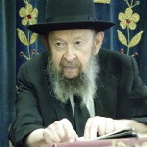

**QUESTION:** What is the best consolation to give someone who is sitting *shiva*, *lo aleichim v’lo aleinu?*

**ANSWER:** To console people, the best thing is to come and show yourself. That’s the consolation. Just by honoring him by coming, that’s already a consolation.

Now, if it’s somebody who’s really broken up, then you have to use words that are suited to the occasion. But you cannot give one prescription that suits everybody.

If a person is of a philosophical bent of mind, so you talk to him about Olam Habah and about this world being only a temporary place; you can talk about how a man who deserves reward was taken by Hakodosh Boruch Hu to *Gan Eden*, and he’s being now treated to all the great promises that Hakodosh Boruch Hu promised to those who serve Him. Whatever it is, there are ways and means of consoling each person according to his *seichel*.

Some people are obtuse; they’re not intelligent so you can’t tell them anything. So all you can say is, “*Vusmachstu* cousin Jake?” That’s all you can say. Now, *vusmachstu* you shouldn’t say because that’s *sh’eilas shalom,* it’s a greeting (see *Yoreh Dei’ah* 385:1), but you speak to him about mundane ordinary things, and that’s the only consolation you can give a man without any brains. So it all depends according to his *seichel*.

*Reprinted from the December 6, 2019 email of Toras Avigdor adapted from Tape #427.*

**90,000 Jews Gather to Pray And Defy a Wave of Hate**

**By Joseph Berger**

**A celebration to mark the end of a cycle of Talmudic study carried extra meaning in the wake of deadly anti-Semitic attacks.**

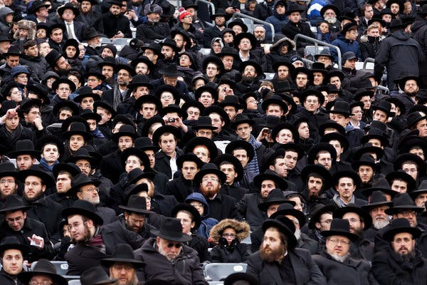

**Celebrants packed the MetLife Stadium on Wednesday, some of the estimated 350,000 Jews all over the world who take part in the movement known as Daf Yomi. (Photo Credit - Jackson Krule for The New York Times)**

EAST RUTHERFORD, N.J. — For the past century, thousands of Jews have participated in a shared and daunting religious feat, reading the same page of the Talmud every day until they finish all 38 volumes of that central text of Jewish religious law and rabbinical debates. The task takes almost seven and a half years to complete and ends in a colossal party.

On Wednesday, Jews thronged MetLife Stadium to mark the occasion, but this time, [a recent nationwide wave of anti-Semitic attacks](https://www.nytimes.com/2019/12/31/nyregion/nyc-anti-semitic-attacks.html) freighted the communal celebration with extra meaning.

On a windy and biting cold day, the gathering offered a chance to affirm their faith [in the face of those terrible acts](https://www.nytimes.com/2018/10/27/us/active-shooter-pittsburgh-synagogue-shooting.html). Some believed the event contained echoes of Jews who were held in ghettos or concentration camps during the Holocaust and resisted their persecutors by saying clandestine prayers, teaching their children the Torah or furtively blowing a ram’s horn on Rosh Hashana.

“You can’t compare it completely, but we’re showing that we’re not going to allow these attacks to change our course, change our language, change our clothing, change our G-d,” said Daniel Retter, an immigration lawyer whose parents escaped Austria under the Nazis and who participated in the Talmudic study with a dozen other members of his synagogue in the Bronx.

An estimated 350,000 Jews all over the world take part in the movement known as Daf Yomi, which means “page a day” in Hebrew. In synagogue study halls, Wall Street board rooms and even on the 7:51 a.m. Long Island Rail Road train from Far Rockaway to Penn Station, they study the same two-sided page each day until all 2,711 are completed.

Many, like Mr. Retter, choose to start the cycle all over again, anticipating new shards of insight or wisdom. Mr. Retter had completed his sixth Daf Yomi cycle.

The movement has become so popular that the [New York-area ceremony on New Year’s Day not only drew 90,000 participants](https://www.nytimes.com/2012/08/02/nyregion/nearly-90000-jews-celebrate-talmud-at-metlife-stadium.html), filling the home of the football Giants and Jets in the New Jersey Meadowlands, but also attracted 20,000 to the Barclays Center in Brooklyn. There were smaller celebrations in 80 cities in 15 countries, according to organizers.

The celebration, known as a Siyum HaShas, or “completion of the Talmud,” was organized by Agudath Israel of America, the ultra-Orthodox umbrella group that initiated the program in 1923 as a way of unifying Jews and their practice in a growing diaspora.

Another organization, Dirshu, also sponsors Daf Yomi study and will hold celebrations at the Prudential Center and two other spaces in New Jersey on Feb. 9.

The vast majority of those in MetLife Stadium were Orthodox men, many from Hasidic and other ultra-Orthodox sects, and their dark suits and hats gave the stadium a charcoal cast. There was a special women’s section so wives and daughters could cheer their men on. Although an increasing number of modern Orthodox women engage in Talmud study, more traditional adherents sharply differentiate gender roles. “We have our role, and the men have their role,” said Avigayil Gleiberman, a 29-year-old bookkeeper who came to the stadium with her husband and extended family. “Although we take Torah classes, the bulk of my day is consumed with work, taking care of my children and supporting my husband.”

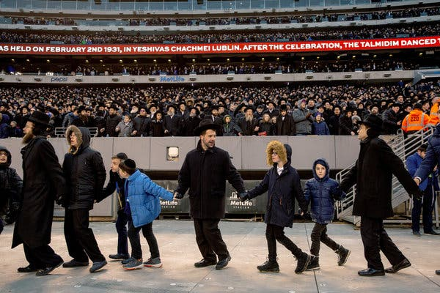

**The stadium program featured speeches, and singing and dancing by men.Credit (Phone Credit - Jackson Krule for The New York Times)**

For some, this year’s celebration did not quite have the exuberance of those in years past. It was shadowed by an unnerving awareness that Jews in the United States have become the targets in the past 14 months of sometimes [deadly anti-Semitic violence in Pittsburgh](https://www.nytimes.com/2019/08/26/us/pittsburgh-synagogue-shooting-death-penalty.html), the San Diego area, [Jersey City, N.J.,](https://www.nytimes.com/2019/12/11/nyregion/jersey-city-shooting.html) and Brooklyn.

On Saturday, a gathering of Orthodox Jews lighting candles for the seventh night of [Hanukkah at a rabbi’s home in the New York suburb of Monsey](https://www.nytimes.com/2019/12/29/nyregion/monsey-new-york-stabbing.html) was invaded by a man wielding a machete. He stabbed five of the guests, leaving one rabbi, Josef Neumann, with a skull fracture. In a statement, Rabbi Neumann’s family said he may not regain consciousness.

Prosecutors have charged [Grafton E. Thomas, who they said had been doing internet searches for “Why did Hitler hate the Jews?”](https://www.nytimes.com/2019/12/30/nyregion/jewish-attacks.html) His family and lawyer have said he has a history of mental illness and no anti-Semitism in his past.

After that attack, the Daf Yomi celebration was seen as not just an act of faith, but one of defiance as well.

“The Talmud has gone through the Crusades, the pogroms, the Holocaust and too many atrocities to name, but the Talmud and the Jewish people have persevered and maintained our roots, and will continue to grow,” said Yossi Gleiberman, a watch importer, father of five and Mrs. Gleiberman’s father-in-law.

The Talmud, assembled between the years 200 and 540, is the central source of Jewish religious law and consists of debates among hundreds of rabbis about the fine legal points gleaned from more generalized teachings in the Torah, the first five books of the Bible. The discussions take in ethics, philosophy, folklore and rituals and cover almost every aspect of an observant Jew’s life.

The stadium program featured a host of speeches, and singing and dancing by men, but its highlight was a reading of the last paragraphs of the final volume of Talmud, the tractate Niddah, concerned with menstruation and other aspects of feminine physiology, followed by a reading of the first sentences of the first volume of the Talmud — Berakhot, or Ritual Blessings — that many will start next week. A special kaddish, a prayer usually recited at a graveside, was chanted at the conclusion of the last page of Niddah.

Like Mr. Retter, many of those at MetLife Stadium were children or grandchildren of Holocaust survivors and had grown up hearing stories of random attacks against Jews. But there is an essential difference between those attacks and more recent ones, Mr. Retter said.

“Now, thank G-d, we live in a nation of grace and favor. The people who enforce the law want to protect us,” Mr. Retter said.

Another member of Mr. Retter’s Daf Yomi group, John Mann, a professor of psychiatry at Columbia University whose parents escaped the Warsaw Ghetto and were liberated at the Bergen-Belsen concentration camp, said the celebration highlighted “continuity and survival itself.”

Persisting in that study, he said, tells the world “we’re not going away. We’re here to stay.”

*Reprinted from the January 1, 2020 website of The New York Times. A version of this article appears in print on Jan. 2, 2020, Section A, Page 15 of the New York edition with the headline: 90,000 Jews Gather to Pray and to Defy a Wave of Hate.*